**Refer the below database schema:-**

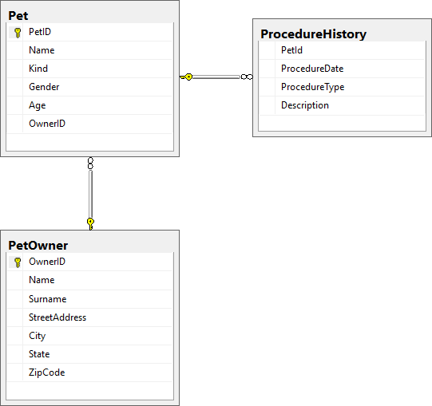

**Sample Dataset:**

**Pet**

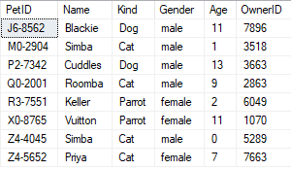

**PetOwner**

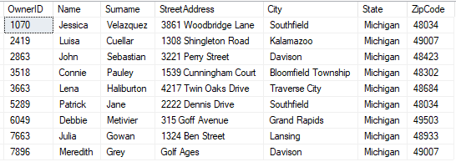

**ProcedureHistory**

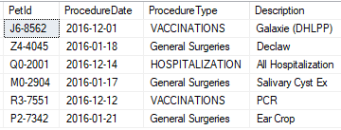

1.     Create a user-defined stored procedure **'usp_PetProcedureDetails'** which takes procedure type as input and will display the pet id, pet name ,owner name, and  description of the procedure. Give alias name to the pet name column as 'Pet Name' and owner name as 'Owner Name'.

**Sample Output:**

The output is for procedure type 'GENERAL SURGERIES'

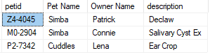

**SAMPLE:**  
**<Line 1>  : Your CREATE Procedure SQL Statement(do not use semicolon - ; to terminate)  
<Line n>  : GO**

USE CodeChallengeDB;

DELIMITER $$

CREATE PROCEDURE `usp_PetProcedureDetails`(IN ProcedureType CHAR(50))

BEGIN

SELECT ProcedureHistory.PetID, Pet.Name AS 'Pet Name', PetOwner.Name AS 'Owner Name', ProcedureHistory.Description

FROM ProcedureHistory

JOIN Pet

JOIN PetOwner

WHERE ProcedureHistory.PetID=Pet.PetID AND Pet.OwnerID=PetOwner.OwnerID AND ProcedureHistory.ProcedureType=ProcedureType;

END$$

CALL usp_PetProcedureDetails('Surgery');